PI Analysis recalculator manager USER’S GUIDE

Version 1.2

# Overview

## Description

The *PI Analysis Recalculator Manager* is a tool to simplify scheduling selective analyses recalculations on large *PI AF* systems. It was built to help users quickly finding and selecting the analyses of interest for backfilling, recalculation and to enable and disabled analyses in bulk.

With this tool, users can retrieve the analyses list based for a target element (including or not the element child elements). Also, they can use combine the root element search with the utilization of analyses filter path to perform a more selective search.

The search returns a list of analyses based on the specific search criteria. In order to easily select the desired analyses for either backfilling or recalculation, you can sort the list by analyses by:

* Analysis path
* Analysis name
* Analysis categories
* Calculation Scheduling info
* Element name
* Element template
* Element categories
* Analysis status

This tool does not provide all functionalities available in *Management* plugin of *PI System Explorer*. You will still need the *Management* plugin to check the analyses backfilling status.

Scenarios where this tool would be helpful:

* You have to select a subset of analyses from an extensive list of analyses, where doing manually in *PI System Explorer* would be very time consuming
* You need to perform recalculation of analyses which outputs are stored in an older version of *PI Data Archive* (prior to 2016 R2), where the explicit deletion of tag values would be required.

## Pre-requisites

The application requires the following components:

* PI AF Client 2016 R2 or later
* PI Analysis Service 2016 R2 or later
* PI Data Archive 2012 or later
* Microsoft .Net Framework 4.8 or later
* [AdvancedDataGridView](https://www.nuget.org/packages/DG.AdvancedDataGridView/1.1.25411.9/License) package

# INSTRUCTIONS

## Searching the analyses of interest

You can search the analyses of all elements in a *PI AF* database, or you can retrieve only the analyses from a specific root element (including or not its child elements). Also, you can retrieve the analyses based on some filter criteria.

Simply follow the steps below:

* Click on **Select Database** button, and pick the *PI AF* database of interest.

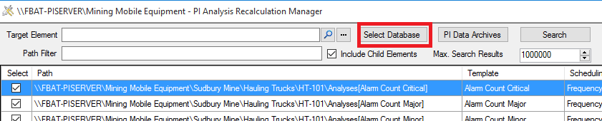

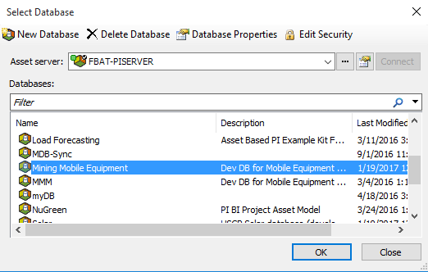

* If you are interested to perform the recalculation for a specific *PI AF* element, click on **…** button and select the *PI AF* element of interest.

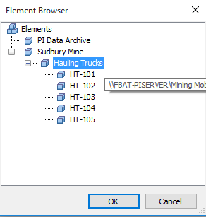

* To include the child elements on the search, check the option **Include Sub-Elements**. Click the **Search** button to see the analysis associated with the target element and their child elements.
  + you can leave the **Target Element** box empty and check the box **Include Sub-Elements** if you want to consider all analyses in the search.
  + To abort the search, click the **Abort** button.
* You can type the filter for the analysis path, using standard PI wildcards characters:
  + **\*** to mask multiple characters
  + **?** to mask a single character

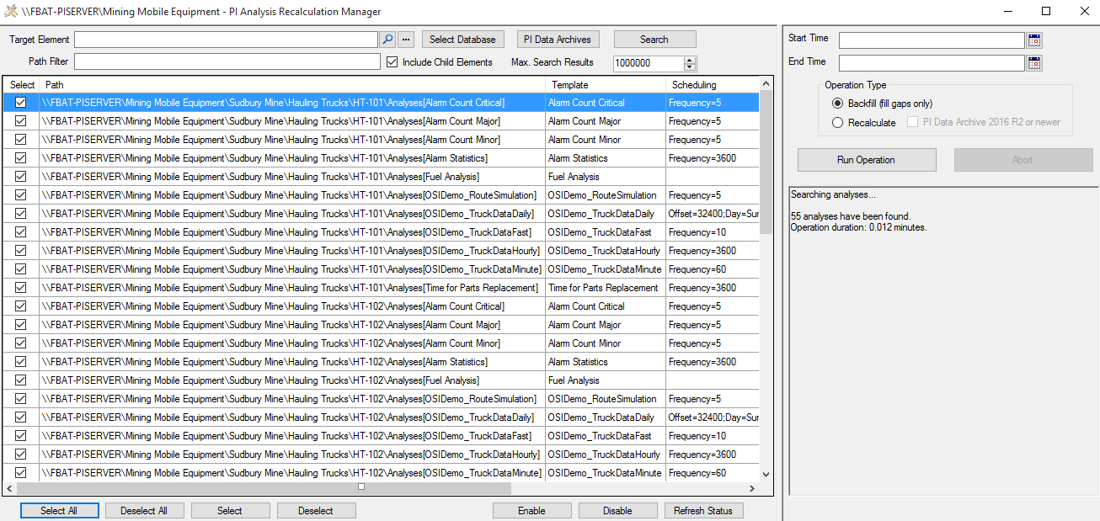

* To sort a column, click on the  symbol located on the desired column and select one of the desired sorting options (A to Z or Z to A), as shown below.

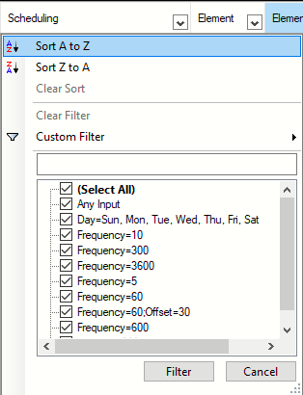

* Advanced filtering capabilities allow you to filter the analysis table (filtering capabilities similar to those of MS Excel).
* Use the buttons below the grid to select / deselect the analysis, and to change the analyses status when necessary.
* If you desire to limit the amount of results returned by the search, set the **Max. Search Results** field accordingly.
* Also, you can delete rows from the analysis list (the actual analyses are not deleted) to reduce the size of the data set, in case you do not need to change the state of recalculate such related analyses.

## Analyses Backfilling

The backfilling will simply fill gaps in the *PI Data Archive*. It assumes there is no data for the backfill interval. Existing data is not going to be replaced in this scenario.

To execute the backfill operation, follow the steps below:

* After selecting the analyses of interest, enter the start and end times for the backfilling/recalculation period (using standard PI time format), and select the option **Backfill (fill gaps only)**

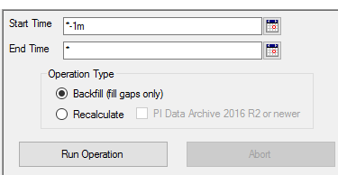

* Click on **Run Operation** to execute the operation. This operation cannot be aborted.
* Analyses that are not showing the *Running* status will be ignored, thus not scheduled for recalculation.

*PI Analysis* service will queue analyses for backfilling and no further action will be required. Check the backfilling status using the *Analyses Management* plugin of *PI System Explorer*.

## Analyses Recalculation

There are 2 modes of recalculation available:

* one for *PI Data Archive* 2016 R2 and newer
* another one for older versions of PI Data Archive

### Recalculation scenario 1: PI Data Archive version is 2016 R2 or newer

If the version of the PI Data Archive used as analyses output repository is 2016 R2 or newer, follow the steps below:

* Select the option **Recalculate** and check the box **PI Data Archive 2016 R2 or newer**.

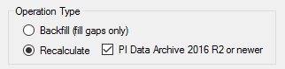

* The program will prompt you to continue or to cancel the operation, since data will be deleted.
  + Click **Yes**, to launch the recalculation (i.e., PI Analysis service will manage the data deletion from the PI Archive, and you will not be able to abort this operation), or

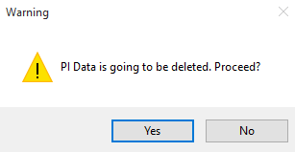

* + Click **No** if you don’t want to delete data in the PI Data Archive.

In this case PI Analyses service will queue analyses for recalculation and no further action will be required. Check the backfilling status using the Analyses Management plugin of PI System Explorer.

### Recalculation scenario 2: older PI Data Archive version

If the option selected is **Recalculate** and the option **PI Data Archive is 2016 R2 or newer** is *NOT* set, this tool will be responsible for deleting the output values prior to analyses recalculation, since PI Analyses will not be able to delete the pre-existing data in the archive for you.

Please follow the steps below:

* Select the option **Recalculate** and keep the box **PI Data Archive 2016 R2 or newer** unchecked.
* The program will prompt you to continue or to cancel the operation, since it requires explicit history data deletion.
  + Choose **Yes**, to have the analyses output history deleted
  + Choose **No** if you do not want to delete analyses output history (in this case the operation will be canceled).

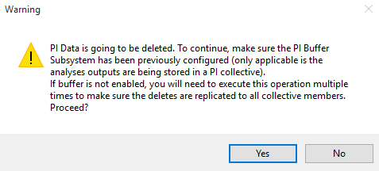

* After the values are deleted, you will be prompted to proceed with the operation. The next step depends on different scenarios:
  + *PI Buffer Subsystem* is running in your computer and properly configured
    - Click **Yes** after making sure that the delete events have already been flushed to the PI Data Archive (standalone of collective), otherwise the *PI Analysis* service will try to backfill the calculations to the time interval that still contains some undeleted data.
  + PI Data Archive used as analyses output repository is in *High Availability* (HA), and the *PI Buffer Subsystem* is disabled in your computer:
    - Click **Cancel**, switch to the next member of the *PI Collective*, and re-run the same operation, until the analysis output values in all collective members are deleted.
    - To switch to another member of the *PI HA* collective, click on the **PI Data Archives** to open the *PI Data Archives* connection window, select the *PI Data Archive* collective name used as the analyses output repository and switch to the desired collective member
    - After deleting the values from all members Click **Yes** to proceed.
  + Stand-alone *PI Data Archive* used as analyses output repository and *PI Buffer Subsystem* not running
    - Simply click **Yes** to proceed.

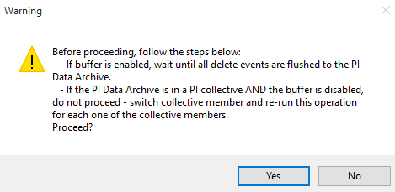

After clicking **Yes**, *PI Analyses* service will queue analyses for backfilling and no further action will be required. Check the backfilling status using the *Analysis Management* plugin of *PI System Explorer*.

## Analysis Status Setting

The status of the selected analyses can be changed to either **Enabled** or **Disabled**. Any selected analysis can be disabled, but only the analysis in the **Disabled** status can be enabled.

### Enabling analyses in bulk

In order to enabled the analyses of interest:

* Select the analysis of interest from the analyses list (by checking the corresponding analysis checkboxes)
* Click the **Enable** button.

You will be informed if any of the selected analyses cannot be enabled. In this case, you will see an informational message like this:

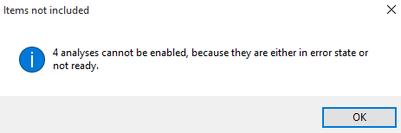

Even if the analysis status may have been changed to **Enabled**, it may go to an error state if the PI Analysis service detects a problem in the analysis. In order to check the current analysis state:

* Click the **Refresh Status** button.

### Disabling analyses in bulk

In order to disable the analyses of interest:

* Select the analysis of interest from the analyses list (by checking the corresponding analysis checkboxes)
* Click the **Disable** button.

# Licensing

Licensed under the Apache License, Version 2.0 (the "License"); you may not use this file except in compliance with the License.

You may obtain a copy of the License at <http://www.apache.org/licenses/LICENSE-2.0>.

Unless required by applicable law or agreed to in writing, software distributed under the License is distributed on an "AS IS" BASIS, WITHOUT WARRANTIES OR CONDITIONS OF ANY KIND, either express or implied. See the License for the specific language governing permissions and limitations under the License.

#### Third-party code

* This software uses the open-source component *AdvancedDataGridView*. For licensing information, please visit <https://www.nuget.org/packages/DG.AdvancedDataGridView/1.1.25411.9/License> .

Some functionality provided in this software leverages the code provided by Rick Davin, published in March 22, 2015 in the following tutorial: “[A faster way to get PIPoints from a large list of AFAttributes](https://pisquare.osisoft.com/message/44314)”.

# REvision history

|  |  |  |  |
| --- | --- | --- | --- |
| Version | Date | Author | Notes |
| 1.0 | 20-Jan-2017 | Fabiano Batista | Initial version |
| 1.2 | 21-Feb-2021 | Fabiano Batista | Describes the functionalities added in version 1.2 |